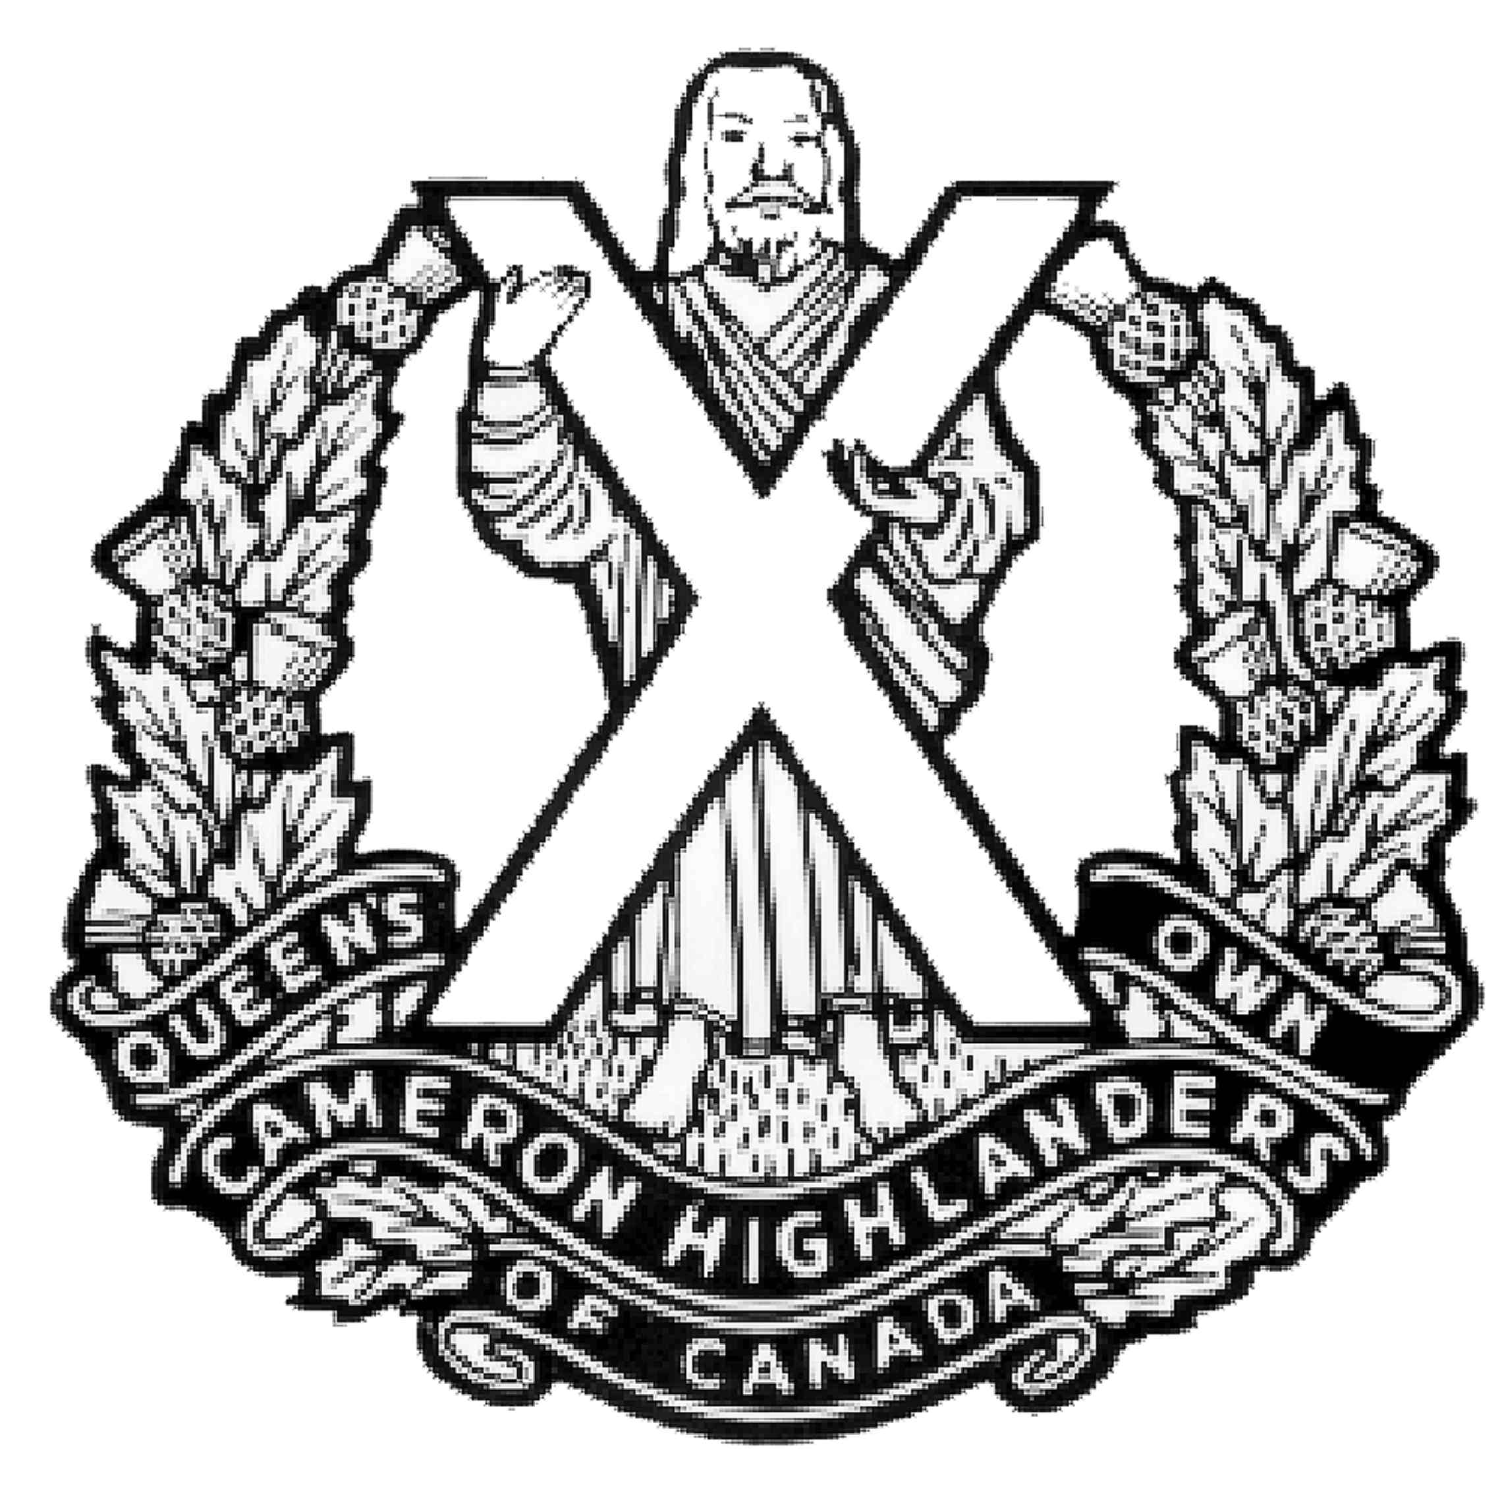

I/we wish to order…….copies of The Queen’s Own Cameron Highlanders of Canada 100th Anniversary Regimental History.

“Winnipeg’s Ladies from Hell”

How The Queen’s Own Cameron Highlanders of Canada fought,
remembered and grew in its first century of war and peace.

Publication and Distribution in Summer 2010

My cheque or money order to cover the cost of $50.00 per book is enclosed.
Includes domestic shipping and handling.
Please make your cheque payable to “QOCH Centenary Inc.”

Name ………………………………

Address ……………………………

City ………………………………...

Province ……………………………

Postal Code ………………………..

Email………………………………

Mail your reply to:
The Queen’s Own Cameron Highlanders Centenary Inc.
Suite 85, PO Box 17000 Stn. Forces, Winnipeg, Manitoba, R3J 3Y5

You may contact us by email at Cameron100@mts.net

